Why hire a fishing-guide?
Most people are still hesitant to hire a fishing guide. So, I will try to is to explain a little bit about what a professional fishing guide does, why you should hire a guide during your holiday, what you as a guest should look for and to what you could compare it to pricewise
The thing that most people forget is all the knowledge, work and years of experience that are put in the profession that is called; “professional fishing-guide”. But it isn’t all about the fishing, if a guide has his own guiding company, a lot of other things need to be taken in consideration too, such as running a business which has insurances, employees, equipment, business- costs, etc.
A professional guide tries to acquire as much information as he can about you as a guest. “Never assume something”, is a saying that always should be in his mind. For each scenario there has to be a plan a, b and c. This goes for weather conditions, water levels, possible health issues that the guests are coping with, when what is hatching, which techniques to use under certain circumstances, which fishing spots are good to go during which circumstances and what is the fishing ability of the guests, how good are they? And now we are just talking about some of the aspects when it comes to the actual fishing.
There are also aspects such as reading the customers, how to teach people to fish in several different ways. A person may not understand a certain way of teaching, so you must adapt your teaching to the guests. You also must be service minded, knowing a lot about the nature and the history of the surroundings that you will are in. This gives you something more to talk about and guests are often interested in these things. Let us not forget some basic knowledge about cooking, indoors as well as outdoors. A good portion of first aid needs to be in place. And have back up plans at hand, a lot of them… the weather turns suddenly foul and the guest does not have the appropriate clothing with him,so bring a tarp for an emergency shelter and some gloves and a scarf. But also bring a spare rod in case his rod breaks, etc.
As you see, a professional fishing guide goes beyond his passion and turns it slowly but steady into a lifestyle. All this acquired knowledge doesn’t come on a plate, ready served. It takes years to achieve this. And that is what you are paying for.
Now we will answer the most important question, why should you hire a fishing guide?
One of the most important reasons is that it saves you time. You do not have the time during a two week holiday to find the right fishing spots that produce the best results during different situations. You do not have the time to find out what the local flies are and which techniques are best suited for different fishing spots and circumstances. A guide has all this knowledge available for you. And he will also, even if you booked him for just one day, give you advice on where to go during the coming days and which flies and techniques you should use.
You have this person beside you who is able to teach you, what you need to know, in several ways. And what normally would take weeks, months or even years for you to learn, could be by the right guide taught to you in a day. Those small little details are what you need to know when it comes to fishing techniques and casting techniques. Sometimes you are just using the wrong equipment or you make just a small movement to the wrong side while casting, which can make all the difference. So if there is something that you want to improve or want to learn this is a very effective and good way to do so.
The next aspect is that a guide knows exactly to which fishing spots he needs to go during different circumstances. This goes for a certain fishing technique that you want to learn, which species you want to fish for, which spots are good during certain weather circumstances etc. Beside the fishing techniques, casting techniques and fishing spots he will teach you what to look for at a fishing spot, how to read the water and what flies to use. All this will and should be explained to you during the trip.
Another very important aspect of a guided trip is the experience itself. Fishing for species that you have never caught before, fishing in a country you have never fished before and showing you what that specific area has to offer when it comes to the fishing and the surrounding nature. All these are important aspects of the whole experience that a guided fishing trip has to offer you.
And have you ever thought about sharing your joy and happiness while fishing with your partner? Often when your partner tries to teach you something the dynamics in a relationship change and it may end up in frustration. One wants to learn and needs a teacher while the other one prefers to fish but likes to do it with the company of their partner instead of teaching it. What better option would there be then to hire a professional fishing guide? He has the knowledge to teach your partner and to point out what they could do to perform better. Because of that, they learn a lot quicker and easier. And future fishing trips with your partner will be more fun and more likely to happen.
When you have a passion for fishing but you have some physical problems, which are normal for people that are getting older, a fishing guide can give you the safety you need and show you the proper spots to fish at as well. So you do not have to miss out on all the fun!
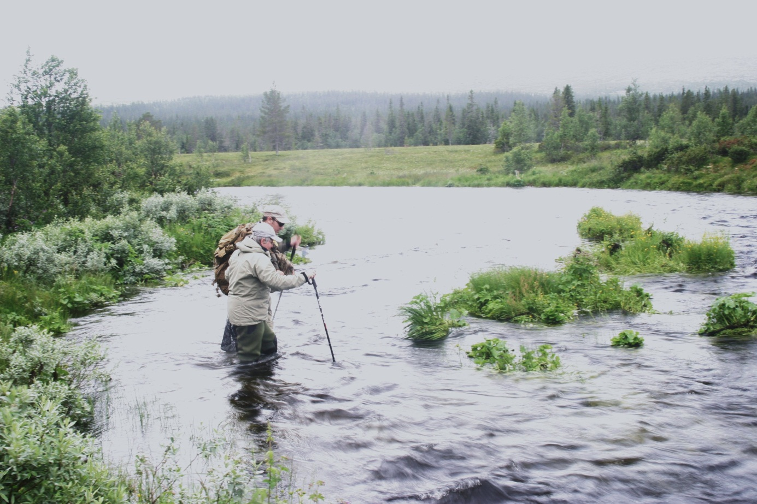
How to find a proper fishing guide?
In some states or countries there are certain rules and associations that a guide has to apply to or to be a member of. This makes it for a “guest to be” a lot easier to select the proper guides. In the countries or states where anyone could call themselves a guide it is always wise to look at the website what the guide is telling about himself. What kind of experience he has, which courses he took, what is his speciality, how long is he guiding, etc.
To find a proper fishing guide can be difficult, but the ones that take their job serious, do promote themselves in a lot of different ways. They write articles, visit shows, have really good informative websites and some guides even make short clips or video’s. They supply their “guests to be” with a lot of information about their type of fishing, what the guests can expect and inform the “guest to be“, about themselves or their company. This information should be readily available to you as a future guest and readily traceable. With this I mean that you can go to the organisation which the professional fishing guide is linked to and find information about this guide and the linked organisation. The most known associations within fly fishing are the EFFA or the FFF. They started out as a American branch and a European branch of certified fly fishing guides. There are also companies that are selling fly fishing equipment. These companies have started a guide certification program such as Orvis. Guides must fulfil certain criteria and take an examination. After completion these guides are proud, and rightly so, to call themselves a certified guide and will also let you know this.
When we look at a completely different kind of sport, where it is common for us to take lessons, then it would be skiing. A ski instructor is asking very quickly between the 100 and 200 euro for an hour, and we are more than willing to pay that. BUT this does not include the daily ski pass, rental equipment and off course a lunch. Now the classes are not for a whole day, most of the time for three to four hours. A whole day fishing will cost anything in between the 400- and 500-euro range.
Now, you got a rough overview of the time and prices. Basically, you will just get a couple of hours skiing, while for the same amount of money you will get a full day with guided fishing. During this full day of guided fishing, you will get a lot more personal guidance and learn therefor a lot more!
So, when you decide to hire a fishing guide, give him the information he needs;
What are your weaknesses and strengths when it comes to fishing and casting techniques, your health such as allergies, fitness level, are you used to walk through the forest and wading in a river, your age and what you want to see and learn from this trip. If you supply a professional fishing guide with this information than he can make a tailor suited trip for you, which can result in an experience that you will never forget!

